 | 보도자료 Press Release
 | 2013년 9월 16일 | 배포 후 바로 보도 가능합니다
 | 총 6 장 | 담당:홍보실 김성연, 오가혜
 | 전화:010-8867-0767  010-4599-8620 | 이메일:communications@asaninst.org

아산정책硏, '아산 북한회의 2013' 25일 개최

세계 최고의 북한 전문가들 집합, 북한 핵 논의

- 아산정책연구원(원장 함재봉, www.asaninst.org)은 오는 25(수)-26(목)일 양일간 서울 신문로 소재 同 연구원에서 제1회 ‘아산 북한회의 2013'을 개최한다.
- 이번 회의에는 미국 랜드연구소 소속 한반도 안보 전문가인 브루스 베넷(Bruce Bennett)을 비롯해 미국 외교협회(CFR) 스콧 스나이더(Scott Snyder) , 칭화대학교 추수롱(Chu Shulong), 야마구치 노보루(Yamaguchi Noboru) 방위정책전문가(전 수상 안보고문), 북한 미사일 전문가 마커스 쉴러(Marcus Schiller) 등 40여 명의 세계 최고의 북한 전문가들과 석학들이 참여한다.
- 참석자들은 북한의 핵능력, 대외관계, 정권의 내구성 등을 다양한 시각에서 분석, 토론하고, 북한의 미래에 대한 전문가적 전망도 내놓는다.

* 참석자 인터뷰를 희망하시면 사전에 신청해 주시기 바랍니다.
(인터뷰 가능자: [별첨] 아젠다 내 하이라이트 표시)
* 회의는 한국어와 영어로 진행되며, 한-영 동시통역이 제공됩니다.
* 기자분들은 ‘PRESS 등록데스크’에서 ‘PRESS 네임텍’을 반드시 수령하시기 바랍니다.
* 금번 회의기간 중 1층 카페가 ‘프레스 룸’으로 운영됩니다.

아산정책연구원 (원장 함재봉, www.asaninst.org)은 객관적이면서 수준 높은 공공정책 연구를 수행하는 독립적인 연구기관입니다. 한반도, 동아시아, 그리고 지구촌의 현안에 대한 깊이 있는 정책 대안을 제시하고, 국민과 정책결정자들이 합리적이고 공공의 복리를 극대화시킬 수 있는 정책을 선택하도록 돕는 싱크탱크의 역할을 지향합니다. 2008년 설립 이후 국내외 학술교류, 아산플래넘, 아산핵포럼과 같은 대규모 국제회의 개최, 《China’s Foreign Policy》, 《Japan in Crisis》, 《출구가 없다》, 《14호 수용소 탈출》연구 서적 출간 등의 활발한 연구활동을 하고 있으며, 2012년 펜실베니아대 주관의 세계싱크탱크 랭킹 지역부문에서는 5위를 차지하였습니다.

참고 자료 1

[아산 북한회의2013] 개요

- 주 최 : 아산정책연구원

- 회 의 명 : ‘아산 북한회의 2013’

- 일 시 : 2013년 9월 25(수) - 9월 26일(목)
Day 1 09:00 ~ 18:00
Day 2 09:00 ~ 17:30

- 장 소 : 아산정책연구원 1층 강당(서울시 신문로 소재)

- 프로그램 개요

- 1일차 : 2013년 9월 25일(수)

- 개막식 – 09:00 ~ 09:30
개회사 (함재봉, 아산정책연구원장)
환영사 (이홍구, 서울국제포럼회장)
기조연설 (류길재, 통일부장관)
- 세션1 – 09:30 ~ 11:00 북한의 핵(North Korea’s Nuclear Capability)
- 세션2 – 11:15 ~ 12:45 북한의 핵전략과 대북 억제력(Nuclear Strategy and Deterrence)
- 세션3 – 14:00 ~ 15:30 대북정책과 국제공조(International Coordination on North Korea)
- 세션4 – 15:45 ~ 17:15 스마트 제재(Smart Sanctions)
- 폐회사 – 17:15 ~ 17:30

- 2일차 : 2013년 9월 26일(목)

- 세션5 – 09:15 ~ 10:45 김정은 체제의 현황(The State of the Korean Regime)
- 세션6 – 11:00 ~ 12:30 북한의 대외관계(North Korea’s External Relations)
- 세션7 – 14:00 ~ 17:30 북한 경제 현황(The State of the North Korean Economy)
- 세션8 – 15:45 ~ 17:15 북한 체제 전망(Long Term Scenario)
- 폐회사 – 17:15 ~ 17:30

참고 자료 2

Conference Agenda

Day 1: Wednesday, September 25

Day 1: Wednesday, September 25, 2013
Time | Panel Title | Panelist | Affiliation
08:30-09:00 | Registration
Opening Ceremony  09:00-09:30 | Welcoming Remarks | Hahm Chaibong | The Asan Institute for Policy Studies
 | Congratulatory Remarks | Lee Hong Koo | The Seoul Forum for International Affairs
 | Keynote Address | Ryoo Kihl-Jae | Ministry of Unification
Session 1  09:30-11:00 | North Korea’s  Nuclear Capability | Lee Chung Min | Yonsei University
 |  | Li Bin | Carnegie Endowment for International Peace/Tsinghua University
 |  | Park Jiyoung | The Asan Institute for Policy Studies
 |  | Joshua Pollack | Science Applications International Corporation
 |  | Markus Schiller | Schmucker Technologie
11:00-11:15 | Coffee Break
Session 2  11:15-12:45 | Nuclear Strategy and Deterrence | Choi Kang | The Asan Institute for Policy Studies
 |  | Robert Manning | The Atlantic Council
 |  | Park Chang Kwoun | Korea Institute for Defense Analyses
 |  | Su Hao | China Foreign Affairs University
 |  | Sugio Takahashi | National Institute for Defense Studies
12:45-14:00 | Lunch
Session 3  14:00-15:30 | International Coordination on  North Korea | Patrick Cronin | Center for a New American Security
 |  | Chu Shulong | Tsinghua University
 |  | Gordon Flake | Mansfield Foundation
 |  | Shin Beomchul | Ministry of Foreign Affairs
 |  | Noboru Yamaguchi | National Defense Academy of Japan
15:30-15:45 | Coffee Break
Session 4  15:45-17:15 | Smart Sanctions | William Newcomb | United Nations
 |  | David Asher | Center for a New American Security
 |  | Kim Joongho | Export-Import Bank of Korea
 |  | William Newcomb | United Nations
 |  | Yang Xiyu | China Institute of International Studies

Day 2: Thursday, September 26

 | Day 2: Thursday, September 26, 2013
 | Time |  | Panel Title |  | Panelist |  | Affiliation
 | 09:00-09:15 |  | Registration
 | Session 5  09:15-10:45 |  | The State of the  North Korean Regime |  | Yoo Ho Yeol |  | Korea University
 |  |  |  |  | Ken Gause |  | CNA
 |  |  |  |  | Jin Qiangyi |  | Yanbian University
 |  |  |  |  | Kim Keun Sik |  | Kyungnam University
 |  |  |  |  | Andrei Lankov |  | Kookmin University
 | 10:45-11:00 |  | Coffee Break
Session 6  11:00-12:30 |  | North Korea’s  External Relations |  | Kim Hankwon |  | The Asan Institute for Policy Studies
 |  |  |  | Cha Du-hyeogn |  | Korea Foundation
 |  |  |  | Narushige Michishita |  | National Graduate Institute for Policy Studies
 |  |  |  | Wei Zhijiang |  | Sun Yat-sen University
 |  |  |  | Alexander Zhebin |  | Institute of Far Eastern Studies, RAS
 | 12:30-14:00 |  | Lunch
Session 7  14:00-15:30 |  | The State of the  North Korean Economy |  | Nick Eberstadt |  | American Enterprise Institute/The Asan Institute for Policy Studies
 |  |  |  | Lee Suk |  | Korea Development Institute
 |  |  |  | Nick Eberstadt |  | American Enterprise Institute/The Asan Institute for Policy Studies
 |  |  |  | Zhang Dongming |  | Liaoning National University
 |  |  |  | Zhang Huizhi |  | Jilin University
15:30-15:45 |  | Coffee Break
Session 8  15:45-17:15 |  | Long Term Scenarios |  | Jo Dongho |  | Ewha Womans University
 |  |  |  | Bruce Bennett |  | RAND Corporation
 |  |  |  | Go Myong-hyun |  | The Asan Institute for Policy Studies
 |  |  |  | Jo Dongho |  | Ewha Womans University
 |  |  |  | Scott Snyder |  | Council on Foreign Relations
 | 17:15-17:30 |  | Closing Remarks

참고 자료 3

국외 주요 참석자

(2013년 9월 12일 현재, 추후 변동 가능 / *성명, 소속)

- 고든 플레이크(Gordon Flake), 맨스필드재단(Mansfield Foundation)
- 나루시게 미치시타(Narushige Michishita), 일본 정책연구대학원(National Graduate Institute for Policy Studies)
- 노보루 야마구치(Noboru Yamaguchi), 일본 방위대학교(National Defense Academy of Japan)
- 니콜라스 에버스타트(Nick Eberstadt), 미국기업연구소/아산정책연구원(American Enterprise Institute/The Asan Institute for Policy Studies)
- 데이비드 애셔(David Asher), 신미국안보센터(CNAS)
- 브루스 베넷(Bruce Bennett), 랜드연구소(RAND Corporation)
- 로버트 매닝(Robert Manning), 애틀랜틱 카운슬(The Atlantic Council))
- 리빈(Li Bin), 카네기평화연구소/칭화대학교(Carnegie Endowment for International Peace/ Tsinghua University)
- 마커스 쉴러(Markus Schiller), 쉬무커 테크놀로기(Schmucker Technologie)
- 수하오(Su Hao), 중국외교학원(China Foreign Affairs University)
- 스콧 스나이더(Scott Snyder), 미국 외교협회(Council on Foreign Relations)
- 안드레이 란코프(Andrei Lankov), 국민대학교(Kookmin University)
- 알렉산더 제빈(Alexander Zhebin), 러시아과학원 극동문제연구소(Institute of Far Eastern Studies at IMEMO)
- 웨이즈장(Wei Zhijiang), 중산대학교(Zhongshan University)
- 윌리엄 뉴콤(William Newcomb), 유엔(United Nations)
- 조슈아 폴락(Joshua Pollack), 미국 과학응용협회(Science Applications International Corporation)
- 추수롱(Chu Shulong), 칭화대학교(Tsinghua University)
- 켄 고스(Ken Gause), 미국 해군분석센터(CAN)
- 패트릭 크로닌(Patrick Cronin), 신미국안보센터(CNAS)

참고 자료 4

PRESS룸 및 등록데스크 위치 안내
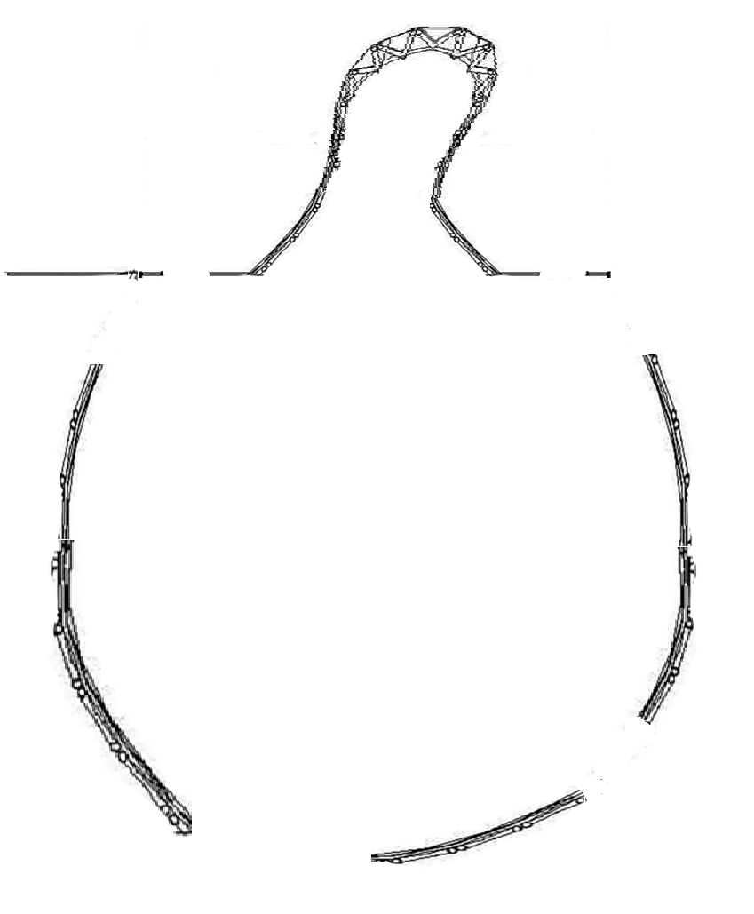

Gallery

Tea table
(Café)
Press Room

Information Desk

Elevator

Press 등록
Registration & Publication Desk
DID
강당
정문(입구)

